**SHORT-TERM CONTRACT FOR MODELLING APPROACHES: SUPPORT TO BFT**

**ASSESSMENT (GBYP 07/2017) OF THE ATLANTIC-WIDE RESEARCH PROGRAMME ON**

**BLUEFIN TUNA (ICCAT-GBYP – Phase 7)**

Tom Carruthers, Blue Matter Science Ltd. (bluemattersci@gmail.com)

16th November 2017

**Progress Report 8** (October – November 2017)

**Executive summary**

MSE development over the last two months has focused on 3 areas:

1. Following completion of the reference set of operating models in September 2017, work has focused on adding the necessary model flexibility (inputs, likelihood functions) to condition the robustness set of operating models (which require, for example, alternative hypotheses about the degree of stock mixing).
2. An additional priority was applying the Bayesian version of the M3 model to obtain posterior MCMC samples of model parameters such that replicate operating models properly represent parameter uncertainty and cross-correlation.
3. The ABT-MSE documentation has been improved to facilitate easier adoption by stakeholders.

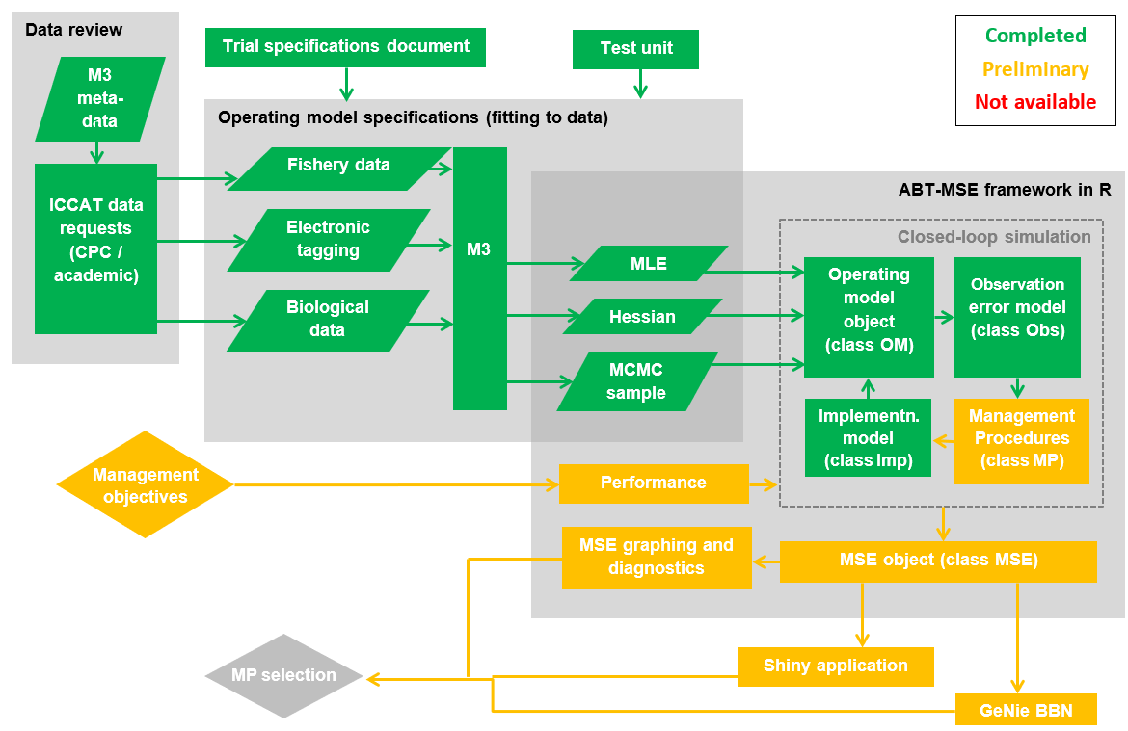

**Figure 1.** MSE status. All components have at least a preliminary version allowing for full use of the MSE framework by other users.

**Progress in current contract since Progress Report 7(October 2017 – November 2017)**

***Conditioning of robustness set operating models***

- Updated the M3 operating model and conditioned additional robustness set

- Added robustness OMs to the ABT-MSE R package

***MCMC operating model samples***

- Operating models parameters are now posterior MCMC samples.

***Documentation of ABT-MSE framework further improved***

- Additional example MPs are coded into the package

- A manuscript testing MPs for multistock fisheries is being drafted.

**Current status of deliverables and actions required to achieve them**

|  |  |  |
| --- | --- | --- |
| **Deliverable 1 July 20, 2016 (100%)** | | |
|  | i | Workplan outlining the actions required to complete the final deliverables |
|  | ii | Presentation and short report summarizing current status of deliverables and actions required to achieve them |
|  |  |  |

The updated workplan (deliverable i) is included below. The purpose of Progress report 6 and accompanying presentations was to address deliverable ii.

|  |  |  |
| --- | --- | --- |
| **Deliverable 2 September 23, 2017 (0%)** | | |
|  | i | Updated presentations and short report summarizing current status of deliverables and actions required to achieve them |
|  | ii | Examples based on agreed trials, to include output statistics and fully OM conditioning diagnostics |
|  | iii | Draft papers on application of MSE |
|  |  |  |

The purpose of progress report 7 is to address deliverable i.

|  |  |  |  |
| --- | --- | --- | --- |
| **Deliverable 3 November 3, 2017 (0%)** | | | |
|  | i | Updated presentations and short report summarizing current status of deliverables and actions required to achieve them |
|  |  |  |

The purpose of progress report 8 is to address deliverable i.

|  |  |  |
| --- | --- | --- |
| **Deliverable 4 February 21, 2018 (0%)** | | |
|  | i | Updated **Repository** with full tracking including version control for software development  <https://github.com/ICCAT/abft-mse> containing the OM |
|  | ii | Update of **SDP** (Software Development Plan) that will be reviewed by external experts, as agreed at Monterey meeting |
|  | iii | **Test Unit** so that code can be validated |
|  | iv | **Meta Database** summarizing all parameters and assumptions used  https://github.com/ICCAT/GBYP-MetaDB |
|  | v | Evaluation of **Management Procedures** implementation by 3rd parties.  Written up as SCRS papers and code available in repository |
|  |  |  |

**Current status of objectives**

|  |  |  |  |
| --- | --- | --- | --- |
| **Objective** | | | **Tasks (bold are completed)** |
|  | **i**  (100%) | Ensure the Operational Model (OM) implements the trials as specified by the 2016 CMG report. | **Added (M3 v1.0):**  **age-based movement, plus group, model initialization at equilibrium estimated F, recruitment predicted from SSB in previous year, a prior for depletion to allow the model to fit specified depletion.** |
|  | **ii**  (100%) | Us the test unit to validate the age-based movement model | **Test unit is being updated to match developments in the operating model** |
|  | **iii**  (0%) | Work with third parties to add MPs to the MSE framework including empirical control rules and simple stock assessment methods | Reach out to national scientists, members of the BFT WG (possibly leverage the chairs of Eastern and Western WGs) and the CMG to develop new MPs or to incorporate existing MPs (e.g. CCSBT) |
|  | **iv**  (0%) | Run the MSE in collaboration with BFT Species group | Requires a dedicated meeting following finalization of the TS, fitting of the appropriate OMs and integration of these into the R ABT-MSE framework. |
|  | **v**  (50%) | Collaborate with the SCRS and others (e.g. rRFMOs) to develop interactive web based graphics to communicate MSE results to decision makers and stakeholders. | A shortlist of scientists has been established who may wish to develop MPs.  Hold a webinar to demonstrate MSE package working.  Collaborate on SCRS papers describing MP performance. |
|  | **vi**  (100%) | Work with other to update and maintain the meta database of the available bluefin data and knowledge <https://github.com/ICCAT/GBYP-MetaDB> | **The meta database has been made publically available and editable** [https://docs.google.com/spreadsheets/d/ 13pFaM3BTnzQ1BNQGoYn4O2n1IeD18V3VTbN9Hv7139U/ edit#gid=1352276725](https://docs.google.com/spreadsheets/d/%2013pFaM3BTnzQ1BNQGoYn4O2n1IeD18V3VTbN9Hv7139U/%20edit) |
|  |  |  |  |

**[From progress report 7] Updated Workplan for achieving deliverables**

***Deliverable 2ii. Examples based on agreed trials, output statistics, conditioning diagnostics***

In the July 2017 CMG meeting, the format for operating model fitting diagnostics was finalized. These were used in SCRS/2017/223 to describe the fit of the 12 operating models to data.

SCRS/2017/224 provides results of two MPs tested using the ABT-MSE R framework including a detailed account of their programming and integration into the package (SCRS/2017/225).

The package now includes standard MSE diagnostics and figures so that users can produce comparable outputs for their custom MPs.

***Deliverable 2iii. Draft papers on applications of MSE***

This was the intention of SCRS/2017/223-225

***Deliverable 4i – 4iv. Updated repository, SDP, test unit, meta database***

These updates will occur nearer to Feb 2018, after finalization of example MPs and operating models.

***Deliverable 4v. Evaluation of Management Procedures implemented by 3rd parties***

1. A list of prospective MP developers was produced at the September 2017 core modelling group meeting.
2. The next step is to reach out to MP developers and provide supporting materials (the ABT-MSE R package and manual / supporting papers).
3. Following this, a short webinar demonstrating MP development and testing in the package might help to further encourage MP development.
4. Finally, MP developers could co-author an SCRS paper (or series of SCRS papers) evaluating MP performance.